PINOYPREZ DOCUMENTATION

By: RENZ MARK C GOROSPE

HOME PAGE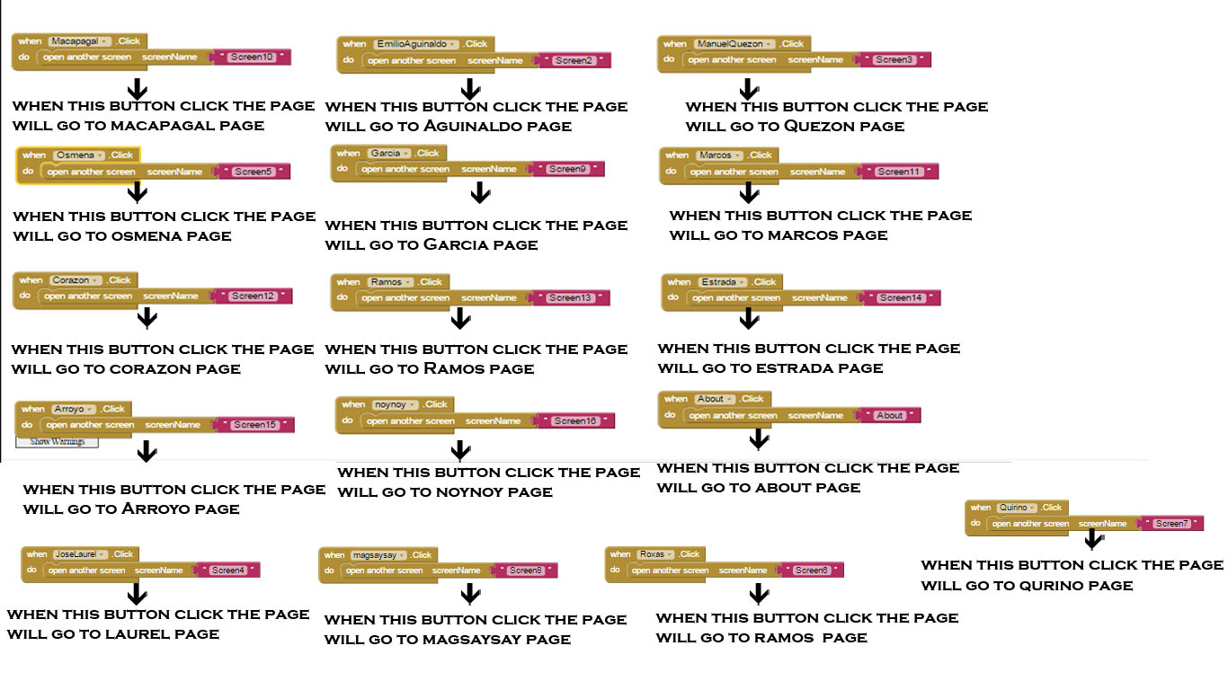

AGUINALDO Page

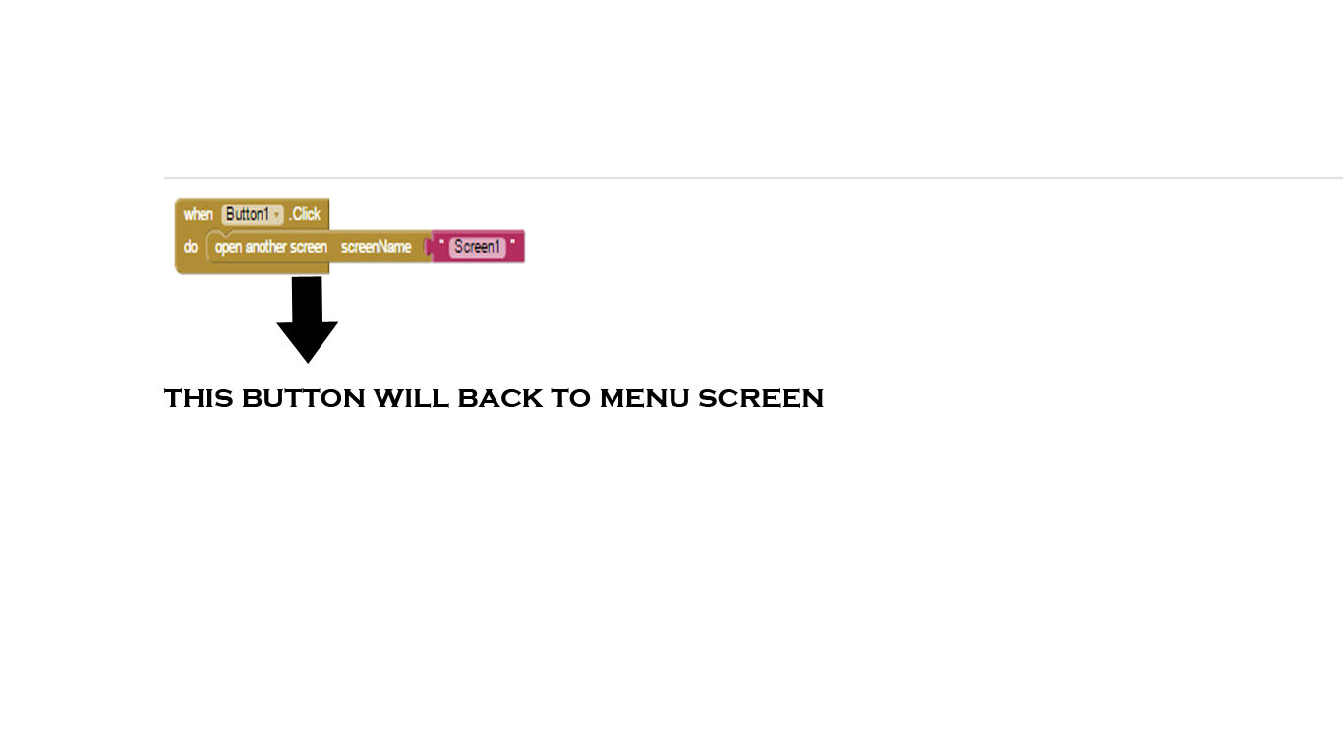

Quezon Page 

Laurel Page

Sergio page



Roxas page

r

Quirini page

MAGSAYSAY PAGE



GARCIA PAGE



MACAPAGAL PAGE



MARCOS PAGE



CORAZON PAGE



RAMOS PAGE



ESTRADA PAGE



GLORIA MACAPAGAL PAGE



AQUINO III PAGE



ABOUT PAGE

